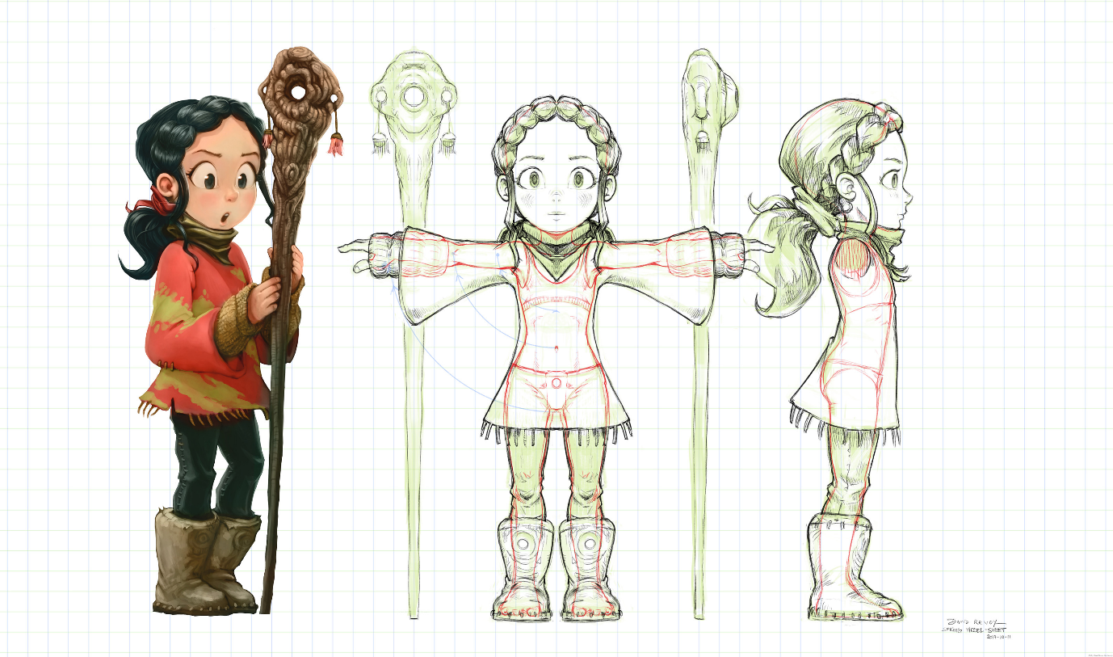
Spring

a creative writing project

The Assignment
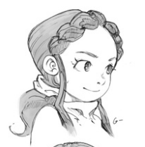
With this creative writing project, you will write part of the ‘Spring’ story with a special focus on descriptions. ‘Spring’ is an open short movie of about seven minutes and can be found here: https://youtu.be/WhWc3b3KhnY (or search on YouTube “Spring Blender”). “Spring is the story of a shepherd girl and her dog, who face ancient spirits in order to continue the cycle of life.”
You will write a part of the story as if somebody reads it in a novel and has no access to the movie; it is a written version of the movie.
Rules:
- Pick up to 1 minute of the movie to use in your writing.
- Write 300-400 words.
- No dialogue is allowed (as there is none in the movie as well).
- Focus on description.
- Hand-in on Moodle.
- Hand-in by the end of week 21.

How to
- Watch the full movie to get a general idea of the story.
- Read the example at the end of this document.
- Pick up to one minute that you would like to tell in words.
- Observe the one minute of video and take notes on whatever you want to describe.
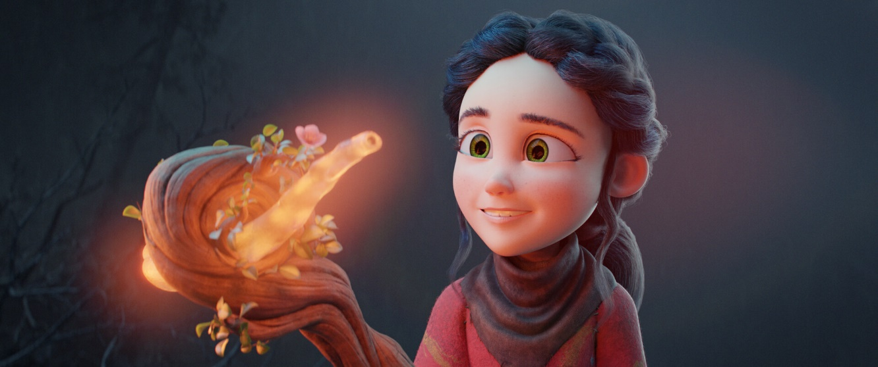
- Write your bit.
Observations
This assignment focuses on writing descriptions. Why is this important? The Writer’s Digest gives us the following on descriptions:
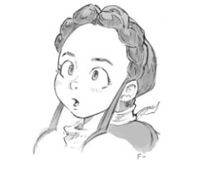
Description can and should be woven throughout your writing, a multicolored thread that binds the whole. So when we talk about creativity and expression, we’re really talking about the ways in which you can give your reader the details and images that will bring your writing to life.
How to enrich your descriptions, The Writer’s Digest

A good describer is a good observer. A good observer notices details and sees things between the lines, both written lines as well as drawn lines. But a writer should not only consider their own observance. They should also take their readers’ observances into account. What can be done to help the reader observe better, what can be hidden to be found on their own? The Writer’s Digest gives us seven ‘eyes’
- The naked eye – This is the biological eye. What do we actually see? What details can be found? Seeing is different from looking at something. Seeing is done deliberately, in other words, with attention. When we look at things, we often unconsciously fill-in gaps or take things for granted. When we take the time to see things, we often notice new details that were already there in first place.
- The eye of memory – The ‘inward eye’, as the poet William Blake once said, ‘is the bliss of solitude’. The eye of memory is the visualisation of things past. The image is often altered, distorted or manipulated as memory is fickle. The ‘eye of memory’ combines the remembrance of ‘the naked eye’ with our views and beliefs on reality. These memories can be moulded into something new and is very helpful in creative writing.
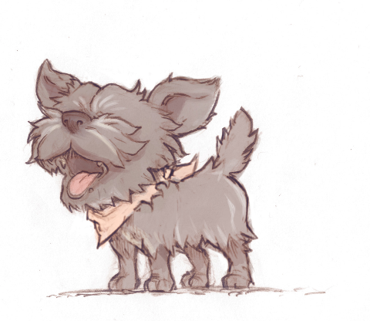
- The third eye – The third eye is seeing things which are implied but not explicitly mentioned. You need the ‘third eye’ to make sense of poetry, but also in everyday life using your third eye helps in understanding people’s behaviour. In writing, you can imply ideas by paying attention to certain details, or order the description in such a way that the reader understands their connection.
- The all-accepting eye – This eye could also be called the ‘scientific eye’, the eye of cold observation. There is no judgment, no sentiment. It is seeing things as they are objectively. The difference with the ‘naked eye’ is that the ‘naked eye’ still has a personal touch. It is your naked eye, which makes choices on what is important and what is not, what has more value and what less?
- The gliding eye – The gliding eye catches things in motion, which are different from static descriptions. The relationship between moving objects changes constantly. You also have to take speed and direction into account.
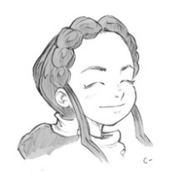
- The child’s eye – The child’s eye is the playful eye. It knows no boundaries, connects ideas to objects and experiments with ideas. The child’s eye combines the ‘naked eye’ with the ‘eye of memory’ and the ‘third eye’. It is not afraid to make mistakes or see silly things. It finds its way through trial and error. A good example of the ‘child’s eye’ is seeing animal forms in passing clouds.
- The dream eye – The dream eye deconstructs reality, which means it cuts reality into separate parts and moves them around adding emotions, ideas and meaning as parts are moved around. The ‘dream eye’ is like the ‘child’s eye’, but is less innocent. Like dreams, the dream eye is fed by underlying ideals and emotions, also from the unconsciousness.
You don’t need all these eyes at the same time, but they show the different approaches of observing events in order to put them into words.

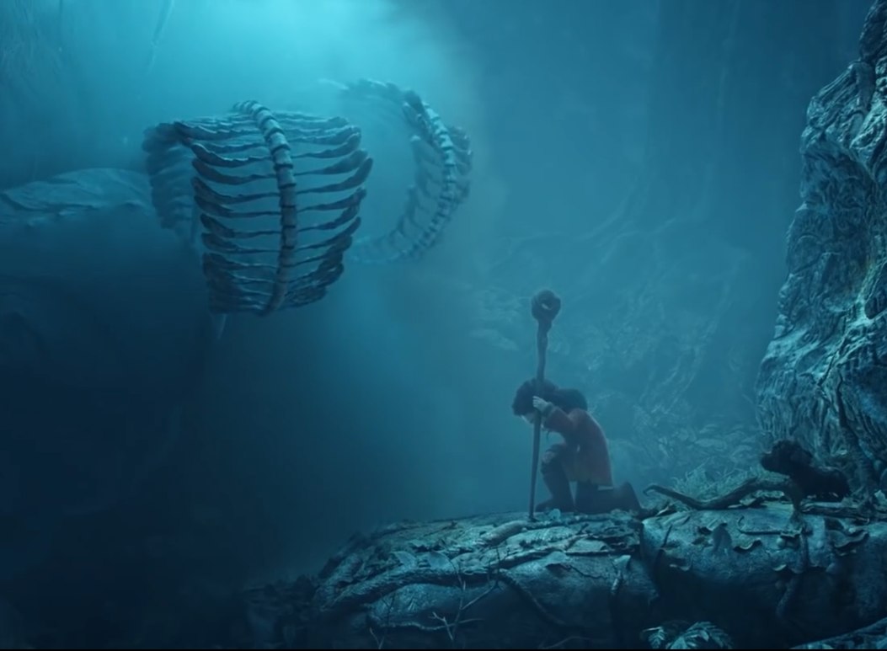
Transforming images into words
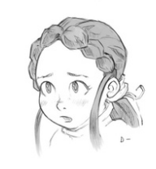
Observing well is one thing, to put them into words is to enter the next level. It is helpful to put descriptions into categories. Like the different ‘eyes’, not all categories are necessary, but consider each one of them. The following list is not limited. You could come up with more categories.
By sensory perception – The five senses (touch, sight, hearing, taste and smell) are our gateways to reality. We often focus in writing on what we see, but smell, for example, can also be a good indicator of a situation, also think of colours, textures and tastes.
By proximity – Proximity means how close things are to each other and their relationship, think of the appearance of a character, a bunch of flowers, items collected on a table.
By quality – With quality we can make divisions and show opposites. Is something more beautiful or less strong, more attractive, or less daunting? You can divide the vivid colours from the dull, the brave from the coward. Quality focuses on what sets it apart.
Chronologically – This is listing events or actions as they happen. The main problem with this category is the notorious ‘and then…, and then…,’. However, chronological descriptions help the reader to make sense of the events that are taking place.
Spatially – The spatial category connects well with the ‘gliding eye’ as it describes motion. Don’t limit yourself to the movements of your main character. Leaves on a tree getting in sudden motion can predict an upcoming storm, something the ‘third eye’ would catch up on.
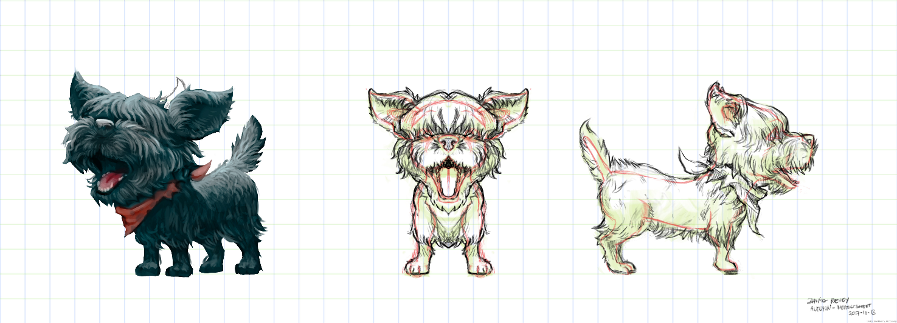

Details and making choices
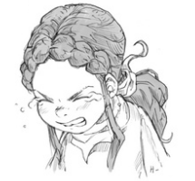
The biggest pitfall of descriptions in creative writing is overdoing it, making your writing a drag. Detail is important, but giving too much meaningless details slackens reading speed and does not help your story going forward. Good descriptions both stir curiosity as well as vivifying the story, but are not too long. They should help the reader in creating a visual image in their mind, without becoming a bore.
So what are meaningful descriptions? The main purpose if descriptive writing is to form an image of the person, thing, action or scene described. Descriptions are meaningful if they are making the described distinctive, that is, making it stand out of the ordinary and tell something about, for example, the character’s background, history, emotional state, or intent.
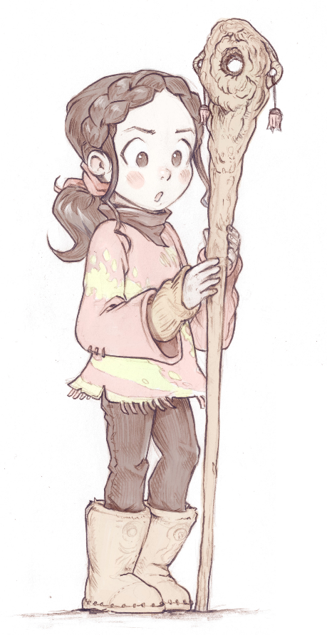
Another reason to use vivid descriptions is to create atmosphere. A lot of scenes are set up by describing the atmosphere of the place. The scene is set and the reader is put into an emotional state even before characters have entered the stage.
Avoid describing things directly into what they represent. So if a place is eerie, don’t describe the place as being ‘eerie’, but describe it indirectly, like a squeaking door, lampposts that have too many cobwebs, a broken window through which a cold wind is howling. Show, don’t tell.

Word choice
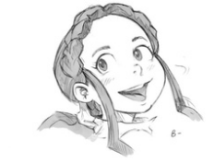
Word choice matters. Length, complexity, and sound all have their effect on the reader. And although some words already have shades of meaning, words that may mean the same, affect the reader differently. Some words may sound more archaic (old-fashioned), or too informal. Some sounds come across as more forceful or comforting. Choosing the right words for your writing goes beyond fictional writing and can be used in formal writing as well.
There is a lot to say about word choice, but for now, the best advice for you is to read your text out loud and consider your word choice on length, complexity and sound. Do they fit the atmosphere and message you want to get across?

Paragraph writing

Using paragraphs is a vital part of writing. Here is a comparison from the chapter “Transforming images into words”:
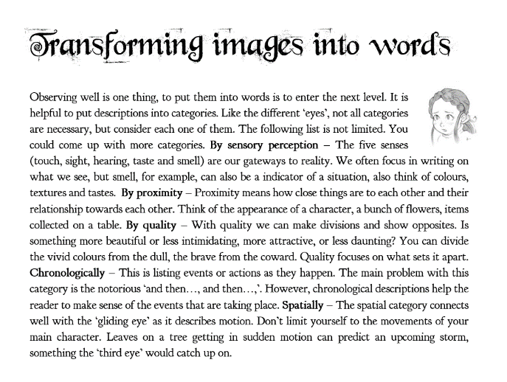
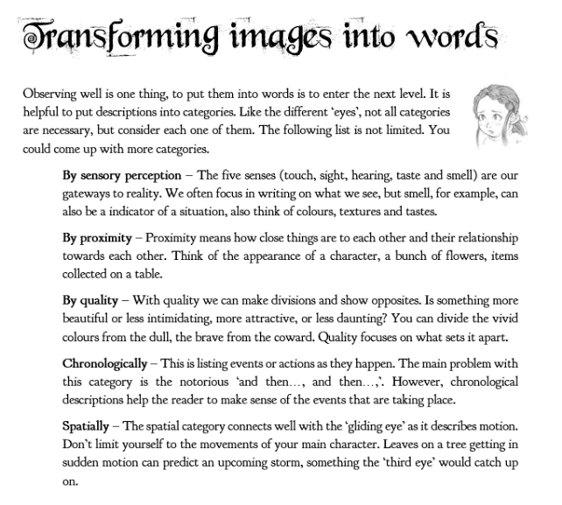

In the first, paragraphs are used to create structure. In the second, the reader has to do more work to make sense of the text. Large chunks of text can also be daunting for readers as they might get lost in the structure of the text.
What is a paragraph? The Next Big Writer website states:
“A paragraph is a collection of sentences that are grouped together around an idea. Often, the first sentence of the paragraph will highlight the idea and then the rest of the sentences will explain and expand upon this. Once the focus shifts to a new idea, then it is time for a new paragraph.”
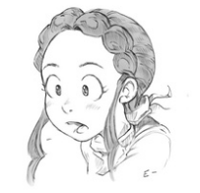
So paragraphs have unity, which means that everything that’s being said revolves around one thing. Once you start something new, you start a new paragraph. But what is this new thing? The Next Big Writer gives us some suggestions:
- a change of perspective
- a shift in location
- a different character speaks
- change of focus or thought
“One way to think about a paragraph is like a movie script. Anytime the scene shifts, or the topic changes, or a character speaks, it's a new paragraph.” Use paragraphs for clarity and to dramatic effect. Cut your story into meaningful parts to get your message across.

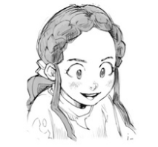
Example from Spring”

01:02 – 01:20 [18 seconds]
She stood up, taking her final bite of her cracker and looking with her dark green eyes at the clouded forest. Getting a better grip on her staff, the shepherd girl frowned. Although she had done her mission for some years now, the task was still daunting as it was dangerous.
The staff was given to her together with her destiny. It was made of beech, entwined and curled, strangely shaped at the top as it unnaturally bent into a circle like a hook. Some scratches were visible within the hook as if a solid object, like a stone, was placed there and removed. From the middle of the staff grew a single leaf, moving on the gentle morning breeze. The leaf was the sign that woke the shepherd girl and set her on this journey. The sign that the world was stirring from a long, wintry sleep.
The shepherd girl looked at that leaf, then looked at the ancient forest and then her eyes focused with intent. She regained her courage to set out on her ancient, annual task. And after a short, deep, and decisive breath she walked determinedly down the grassy hills. Her dog, getting its stick, trod behind her; tail up, in playful manner, unbeknownst of its crucial part in this year’s story.
The pebbly road winded down towards the edge of the forest. It was tricky and she had to be careful to keep her balance. Lower down the hill the path disappeared into the wood. It contrasted the grassy mountains from where she came. As she descended, she hardly saw the forest as it was hidden in an ocean of mist between two mountain tops. The gathered mist proclaimed some hidden secret to be unleashed. Today would be no different. Today the circle would start again.

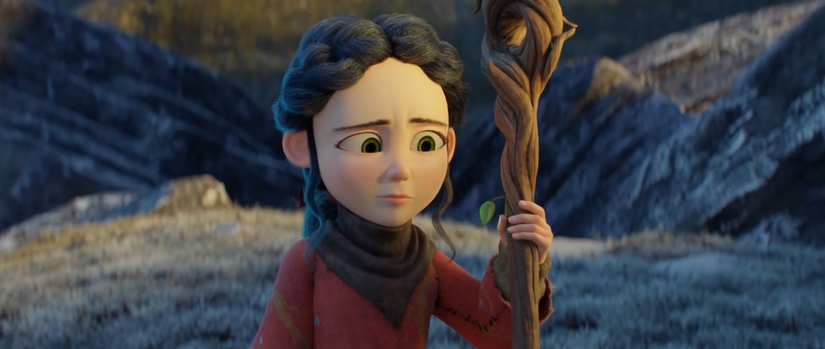
[302 words]

Spring description at YouTube video.
The Next Big Writer, How to Use Paragraphs in Creative Writing, <www.thenextbigwriter.com>

